by Lukas Setiawan

e-mail: [lukassetiawan@yahoo.com](mailto:lukassetiawan@yahoo.com)

(Oct 31, 2024)

**EXTENDED FALSE POSITION METHOD**

For finding multiple  roots simultaneously of the continuous function.

**Here is the idea(algorithm) :**

* Input interval [a,b] where the multiple roots located.
* Input gamma as variable to calculate ∆x, where ∆x=abs(gamma * a), e.g. [a,b]=[-10,10],gamma=1% or 0.01 so ∆x=abs(0.01 * (-10))=0.1. We can increase or decrease gamma as input variable. If (a=0) then ∆x=abs(gamma * b).
* From x=a as  left boundary or starting point, we calculate f(x) to know the sign(negative/positive).
* Then we move to x+∆x, make calculate f(x+∆x) also. If f(x) and f(x+∆x) have opposite sign, means graph crossing x-axis or root found. If root found, we use False Position method to get value of the root.
* If after one iteration, we got no root then we move to new x and x+∆x with the increment is ∆x.
* We continue make same process till got opposite sign.
* If the first root found, then store it to the array.
* We do same process till reach b as the right boundary.
* Finally we got all roots.
* Done.

**False Position Formula :**

$$c_{i}=b_{i}−\frac{f(b_{i})(b_{i}−a_{i})}{f(b_{i})−f(a_{i})}$$

*for i = 0,1,2,…..,n*

Latex version:

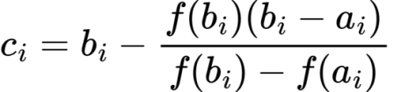

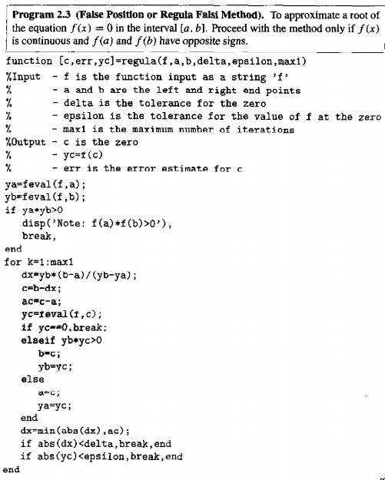

(took from the book Numerical method using Matlab third edition 1999 by John H. Mathews and Kurtis D. Fink).